MINISTRY OF AGRICULTURE AND RURAL DEVELOPMENT
IRRIGATION PROJECTS CENTRAL PROJECT OFFICE
-----

MEKONG DELTA INTEGRATED CLIMATE RESILIENCE AND SUSTAINABLE LIVELIHOODS PROJECT

RESETTLEMENT ACTION PLAN

SUBPROJECT 1: ADDRESSING COASTAL AND RIVERBANK EROSION IN MEKONG DELTA

CA MAU PROVINCE

Ca Mau, 5/2020

MINISTRY OF AGRICULTURE AND RURAL DEVELOPMENT
IRRIGATION PROJECTS CENTRAL PROJECT OFFICE

MEKONG DELTA INTEGRATED CLIMATE RESILIENCE AND SUSTAINABLE LIVELIHOODS PROJECT

RESETTLEMENT ACTION PLAN

SUBPROJECT 1: ADDRESSING COASTAL AND RIVERBANK EROSION IN MEKONG DELTA

CA MAU PROVINCE

PROJECT OWNER | CONSULTANCY AGENCY

TABLE OF CONTENTS
1. PROJECT OVERVIEW 1
1.1. Background 1
1.2. Subproject 1: Addressing Coastal and Riverbank Erosion in Mekong Delta - Ca Mau province 1
2. OBJECTIVES OF RESETTLEMENT ACTION PLAN 2
3. SCOPE OF LAND ACQUISITION AND RESETTLEMENT (LAR) 4
3.1. Mitigation measures of land acquisition and resettlement 4
3.2. Scope of land acquisition and resettlement 4
3.2.1. Number of permanently affected households by the Subproject 4
3.2.2. Temporary impacts during construction 5
3.3. Related projects 5
4. LEGAL FRAMEWORK 6
4.1. The World Bank’s Operation Policy on Involuntary Resettlement 6
4.2. The Legal framework of the Government of Vietnam: 6
4.3. Socio-economic information of affected households 8
4.4. Gender issues 13
5. COMPENSATION, ASSISTANCE AND RESETTLEMENT POLICIES 14
5.1. Resettlement priciples of the subproject 14
5.2. Policies on compensation, support and resettlement of the subproject 15
6. ELIGIBILITY CRITERIA AND ENTITLEMENTS 18
6.1. Project affected people (PAPs) 18
6.2. Eligibility 18
6.3. New households after the cut-off-date 18
7. PARTICIPATION, CONSULTATION AND INFORMATION DISCLOSURE 19
7.1. Objectives 19
7.2. Information disclosure and consultation 19
8. GRIEVANCE AND REDRESS MECHANISM 23
8.1. Responsibilities 23
8.2. Grievance redress mechanism 24
9. IMPLEMENTATION ARRANGEMENT 26
9.1. Responsibilities of relevant agencies 26
9.2. Updating Resettlement Action Plan 28
10. IMPLEMENTATION PLAN 29
10.1. Main activities 29
10.2. Implementation plan 29
11. SUPERVISION, MONITORING AND EVALUATION 31
11.1. Objectives of monitoring 31
11.2. Internal monitoring and supervision 31
11.3. External monitoring 32
12. COST ESTIMATION AND BUDGET 32
12.1. Funding sources 32
12.2. Cost estimation and funding source 32
ANNEX 34

LIST OF TABLES

Table 1: Statistics of location and length of each embankment section 3
Table 2: Socio-economic information in subproject districts 10
Table 3: Socio-economic information in the subproject communes 11
Table 4: Information of surveyed households 12
Table 5: Information of respondent’s age 12
Table 6: Assignment of family work 13
Table 7: Matrix of Entitlements 17
Table 8: Summary of public consultations during the subproject preparation 21
Table 9: The RAP implementation plan of Ca Mau subproject 29
Table 10: Cost estimate for compensation by the subproject 32

ANNEXES
Annex 1: Some minutes of consultation in the subproject communes 34
Annex 2: Some photos of the scene and community consultation 43
Annex 3: Project Information Booklet 45
Annex 4: IOL form 47

CURRENCY EQUIVALENTS
(December 2019)
Currency | – | Vietnam Dong (VND)
$1.00 | = | VND 23,250

ABBREVIATIONS
PAP/AH | Project affected people/affected household
CPO | Irrigation Projects Central Management Office
ICRSL | Mekong Delta Integrated Climate Resilience and Sustainable Livelihoods Project
RAP | Resettlement Action Plan
MARD | Ministry of Agriculture and Rural Development
DARD | Department of Agriculture and Rural Development
WB | World Bank
PPC | Provincial People's Committee
PMU | Provincial Project Management Unit
PC | People's Committee
IOL | Inventory of loss
DMS | Detailed measurement survey
VND | Vietnamese Dong
WB | Work Bank
GOV | Vietnamese government

DEFINITION OF TERMS
Project impacts | Any consequences directly related to land acquisition or restriction of the use of legally selected areas or protected areas.
Affected people | Any person, affected by the implementation of a project affecting the loss of ownership, use, or loss of income or means of livelihood such as construction works, land (residential land, agricultural land or pasture land), annual or perennial crops and plants or other impacts regardless of relocation, in whole or in part, permanent or temporary.
Cut-off date | The date on which the competent authority issued a notice of land acquisition to the relevant project (Clause 1, Article 67 of Land Law 2013) before conducting a detailed measurement survey (DMS). An impact assessment survey (census) will be conducted before the cut-off date is published to make list of possible affected households.
Eligibility | Any person who has used the land affected by the project and is listed before the cut-off date that (i) has legal land use rights; (ii) do not have a legal land use right but are eligible to be legally recognized pursuant to national law; and (iii) not to be claimed a lawful use right or a claim of the right to use the land they are occupying.
Replacement cost (price) | - For agricultural land, the replacement cost is the market price at the time prior to the project implementation or before the relocation for the project implementation (upon whichever is higher) of the equivalent production or use value of land in the adjacent area to the affected area, plus land reclamation costs to achieve an equivalent value of such affected land, and plus costs applied to registration and transfer taxes.  - For residential land in urban areas, it is the market price at the time prior to the relocation of a land of the same size and use purpose, with similar or good infrastructure and public services compared with the previous residence and in the vicinity of the affected land, plus the costs applied to registration and transfer taxes.  - For houses and structures, the market price of materials will be applied to build replacement structures of equal or better quality than affected ones, or to repair partially damaged ones, plus costs of transporting construction materials to the construction site, plus labor costs and costs for construction contractors, plus costs of transporting construction materials to the construction site, plus labor costs and costs for construction contractors, and plus fees and duties applicable for registration and transfer taxes. The determination of replacement costs is regardless of the depreciation of assets and the value of liquidated materials as well as the value of benefits from the project that has deducted the value of affected assets.
Resettlement | Including all direct economic and social damages caused by land acquisition and limited access to assets, along with subsequent compensation and remedies. Resettlement is not restricted to house relocation. Resettlement may, on a case-by-case basis, include (i) acquisition of land and structures on such land, including business activities; (ii) relocation of house and structures; and (iii) rehabilitation measures to improve (or at least restore) income and living standards of affected people.
Entitlements | Including compensation and assistance to affected people based on types and extents of damages.
Inventory of loss (IOL) | A process of calculating assets and sources of income affected by project.
Baseline socio-economic survey | A baseline socio-economic survey of households, businesses, or parties affected by other projects required to: Accurately identify and compensate or minimize damage, assess impacts, on household economy, and differentiate levels of impacts on affected parties.
Vulnerable groups | Identified as persons due to their gender, ethnicity, age, physical or mental disability, economic disadvantages or social status, which are more severely affected by resettlement than other communities and those who are limited by their ability to request support to develop their benefits from project, including: (i) female-headed households with dependents (without husbands, husbands who were dead, husbands who are incapable of working); (ii) people with disabilities (no longer able to work), old people who have no one to rely on; (iii) poor and near poor households; (iv) people who don’t have land; (v) ethnic minorities; and (vi) policy households.
Livelihoods | Economic activities and income generation, often by self-employment and/or labor paid by their own labor and materials to earn sufficient income to meet the requirements of themselves and their families sustainably.
Income (livelihood) restoration | Restoring income or livelihood of affected households.
Stakeholders | Any and all individuals, groups, organizations, and institutions that are interested and likely affected by the project or may affect the project.

EXECUTIVE SUMMARY
- The Government of Vietnam has received a credit of the International Development Association (IDA) to finance the Mekong Delta Integrated Climate Resilience and Sustainable Livelihoods Project (MD-ICRSL Project). The Project has started since the third quarter of 2016 with the development objective of "Strengthening tools for planning and adapting to climate change and improving resilience to climate change for land and water resource management in the selected provinces in the Mekong Delta". Subproject 01: "Addressing Coastal and Riverbank Erosion in Mekong Delta - Ca Mau Province" is part of Component 2 - Managing Upstream Floods - Mekong Delta Integrated Climate Resilience and Sustainable Livelihoods Project (MD-ICRSL Project). This Resettlement Action Plan (RAP) is prepared for 02 work-items "Embankments against landslides in Vam Xoay area, Dat Mui commune, Ngoc Hien district” and “Embankment against landslides in Ho Gui area in Nguyen Huan commune, Dam Doi district , Ca Mau province". This RAP is based on the Project's Resettlement Policy Framework and socio-economic survey results, inventory of loss (IOL), and community consultation.
- Scope and impact of land acquisition. The subproject does not cause permanent land acquisition on households because it is built entirely at sea. The subproject will cover 02 communes: Dat Mui commune (Ngoc Hien district) and Nguyen Huan commune (Dam Doi district).
- During the subproject implementation, there will be temporary impacts on aquaculture and fishing activities of 09 households in 02 communes. It is estimated that the temporary affected area of ​​09 households is about 15,000m2. The households rent this land area from the commune People's Committee for aquaculture. In addition, during the subproject implementation, about 300 m2 of public land of the Commune People's Committee is estimated to be temporarily affected by the subproject for materials gathering, building bypass, and material transportation...
- Entitlement and policy framework. The Resettlement Policy Framework has been developed based on the current policies and decisions of the Vietnamese government and the World Bank's Operational Policy (WB) on involuntary resettlement (OP 4.12). This document will guide the preparation of the resettlement action plan and the implementation of resettlement for the subproject. In case of discrepancies between the Vietnamese and World Bank’s policies, the World Bank's policy will be applied.
- Principles and policies on compensation and assistance. The overall objective of this Resettlement Action Plan is to ensure that all project affected persons will receive compensation at replacement costs. In addition, assistances will be provided to vulnerable households to restore their income and living conditions to at least equal or high levels than their livelihood conditions before the subproject implementation.
- Community consultation and participation. Affected households and beneficiaries will participate in community consultation meetings to get subproject information, subproject impacts and give comments and recommendations for the implementation of the resettlement plan. Feedback obtained from consultations is reflected in this resettlement action plan.
- Implementation process. The resettlement, compensation and assistance tasks will be carried out by the Land Fund Development Center (LFDC), PPMU, and the Central Project Office of Irrigation Projects (CPO) and the internal monitoring agency. During the implementation process, it is necessary to coordinate closely with the implementing units such as the CLFD, PPMU, local agencies, local authorities, local social organizations and affected people in the subproject area.
- Monitoring and evaluation. The staff of the PPMU and the CPO will monitor the implementation of RAP. In this subproject, only temporary impacts are anticipated. Therefore, internal monitoring is sufficient. After DMS completed, the impacts will be updated, if the impacts are significant (land, assets), the need to hire the independent monitoring agency will be re-decided.
- Complaints and grievance redress mechanism. In order to ensure that all grievances of affected persons on land acquisition, compensation and resettlement are addressed promptly and satisfactorily, a grievance redress mechanism is set up in the Resettlement Action Plan. All affected persons can submit complaints and written questions about entitlements, compensation rates, support, income restoration.... The grievances redress process includes 3 levels (CPCs, DPCs, and PPCs) If complainers do not agree with the outcome of settlement of their complaints, they can send their complaints to the courts, whenever they wish. The PMU will appoint a staff member to oversee and follow up the grievances of the DPs until they are settled.
- Funding source. The total cost estimate for implementation of the subproject’s RAP is VND 125,718,120 (equivalent to 5,407.23, exchange rate VND 23,250 = 1 USD). This budget includes compensation/support costs for transportation allowance, implementation management cost and contingency cost. This cost estimate will be taken from the counterpart funding of the People's Committee of Ca Mau province.

PROJECT OVERVIEW
  - Background
- The Government of Vietnam has received a credit of the International Development Association (IDA) to finance the Mekong Delta Integrated Climate Resilience and Sustainable Livelihoods Project (MD-ICRSL Project). The Project has started since the third quarter of 2016 with the development objective of "Strengthening tools for planning and adapting to climate change and improving resilience to climate change for land and water resource management in the selected provinces in the Mekong Delta". The total investment of the Project is USD 385.9 million (USD 310 million is financed by the IDA; USD 72.5 million is financed by the Government's counterpart fund; and USD 2.4 million is from private capital).
  - Subproject 1: Addressing Coastal and Riverbank Erosion in Mekong Delta - Ca Mau province
- General objectives: Overcoming erosion of river and coastal banks, protecting coastal population, infrastructure and land, enabling livelihoods stabilization and development, and improving incomes for people in the subproject area.
- Specific objectives: Eradicating erosion at selected critical (emergency) locations, promoting land and water management better and improving disaster resilience under climate change and sea level rise conditions in selected provinces in the Mekong Delta.
- Subproject 1: "Addressing Coastal and Riverbank Erosion in Mekong Delta - Ca Mau Province" is proposed to build 02 work-items:
- “Embankment against landslides in Vam Xoay area” Dat Mui commune (Ngoc Hien district); and
- “Embankment against landslides in Ho Gui area” in Nguyen Huan commune (Dam Doi district).
- Severe erosion occurs in Vam Xoay estuary. On average, the protective forest belt losses 80m -100m per year and in somewhere landslides have been cut deep, making jaws inside. This directly affects residential areas, administrative areas, state agencies of Dat Mui commune, Ngoc Hien district. The preliminary estimates show that when the "Embankment against landslides in Vam Xoay area” is completed, it will protect about 270 households (with 1,080 people) in the concentrated residential areas of ​​Vam Xoay estuary, protect Ho Chi Minh highway, high and medium voltage lines, health stations, schools ...., and protect and restore very important protective forest belt in the East Coast and the world's biosphere reserve (the Ramsar) etc.
- Severe erosion also occurs in Ho Gui estuary, affecting the ​​coastal mangrove protective forests, and in somewhere affecting the local ​​aquaculture. The preliminary estimates show that when the "Embankment against landslides in Ho Gui area” is completed, it will protect about 639 households (with 2,556 people) and about 2,354 ha​​ of agricultural land and aquacultural land is directly and indirectly protected. In addition, the construction of the subproject will protect and restore the very important protective forest belt in the East Coast. The construction of the subproject is relevant with people’s expectation and help them stabilize their lives, which makes people feel secure in fishing and aquaculture production.

OBJECTIVES OF RESETTLEMENT ACTION PLAN
  - Objectives of Resettlement Action Plan
- The Resettlement Action Plan for Ca Mau subproject is based on the Resettlement Policy Framework (RPF) of the project approved by the Prime Minister of Vietnam and the Donor before the agreement negotiations proceed, which harmonizes the operational policy of World Bank OP 4.12 and the GOV's regulations on compensation, assistance and resettlement. This Resettlement Action Plan (RAP) has been prepared for the subproject item, providing guidance for activities related to compensation for land acquisition during the implementation of subproject work items. The overall objective of the RAP is to ensure that all affected households will receive compensation at replacement costs for their losses and to be provided with supports/assistances to restore their livelihoods - at least with their pre-subproject implementation levels.
- Based on these principles, the main objectives of the Resettlement Action Plan are as follows:
- Ensure complete and accurate determination of impacts, damages on land, structures, and other assets of all affected individuals and organizations.
- Develop criteria, conditions and entitlements on compensation, support and resettlement; establish compensation rates for affected assets; and describe the levels of supports/assistances for affected households.
- Ensure adequate and timely funding to pay compensation and support to affected households.
- Ensure that the land acquisition and handover of sites to carry out the construction works are on time and in pace of the general schedule of the whole project.
- Encourage affected persons and communities to participate in the process of preparing, implementing and monitoring the Resettlement Action Plan.
- Establish a grievance redress mechanism to ensure that all grievances of affected persons will be handled in a timely, satisfactory and transparent manner.
- Establish a mechanism for consultation, participation and supervision for affected households.
  - Scope of Resettlement Action Plan
- The RAP report is based on the basic designs of the subproject. It will be kept updated after the detailed designs, detailed measurement surveys (DMS), and replacement cost surveys are finalized. This resettlement action plan will serve as a guide for the activities related to compensation and land acquisition during the implementation of the subproject work-item that require land acquisition, compensation, and resettlement.
- Subproject 1: "Addressing Coastal and Riverbank Erosion in Mekong Delta - Ca Mau Province" is proposed to build 02 work-items: “Embankment against landslides in Vam Xoay area” in Dat Mui commune, Ngoc Hien district with a length of 4.87 km, and “Embankment against landslides in Ho Gui area” in Nguyen Huan commune, Dam Doi district, with a length of 3.5 km. This RAP report is prepared for this work-item and the details of work are presented in the following table.

Table 1: Statistics of location and length of each embankment section
No. | Names of embankment sections | Length (km) | Locations
1 | Embankment against landslides in Vam Xoay area | 4.87 | Dat Mui commune, Ngoc Hien district
2 | Embankment against landslides in Ho Gui area | 3.5 | Nguyen Huan commune, Dam Doi district
(Source: Project proposal,10/2018)

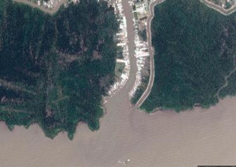 | 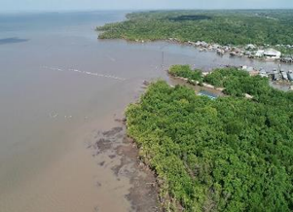
Construction area of Embankment against landslides in Vam Xoay area
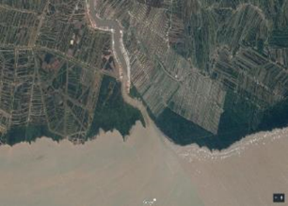 | 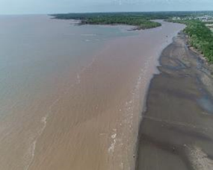
Construction area of Embankment against landslides in Ho Gui area

SCOPE OF LAND ACQUISITION AND RESETTLEMENT (LAR)

Mitigation measures of land acquisition and resettlement
- In order to minimize subproject impacts on households, including directly and indirectly affected households, the mitigation measures have been implemented as follows:
- During the subproject preparation, the Consultant that develops RAP, the Consultant that develops feasibility study report, and the PPMU worked closely in making technical measures, comparing and selecting methods according to the principle of minimizing impacts of land acquisition of households in the subproject area, and the priority was given to the options of less land acquisition (site clearance) or the use of state-owned public land as follows: The construction site of the embankment is located in the coastal area and the construction is entirely out of the sea, therefore, it does not affect land and affect people living around. The construction of works only causes disruption of fishing and aquaculture activities of some households (during construction).
- During the process of the subproject preparation and the RAP preparation as well, the PPMU and the Resettlement Consultant held consultations with the stakeholders and affected households in the subproject area to make public on: (i) Subproject information; (ii) anticipated impacts due to the subproject implementation; (iii) information on cut-off date; (iv) summary of the grievance redress mechanism; and (v) entitlements and policies of the subproject .... In the consultations, a lot of issues were discussed such as compensation and support policy, project design options and mitigation measures. All people are very supportive and look forward to the subproject's early implementation.
- To minimize impacts on households doing fishing and aquaculture during the construction phase, the Resettlement Consultant has consulted with local authorities and households in the subproject area to propose appropriate mitigation measures to each locality. Accordingly, a number of mitigation measures during the construction process will be applied, e.g. completion of construction of section by section, appropriate time of construction etc.
- The construction time will be publicly announced according to regulations to local authorities and affected households so that AHs can arrange suitable aquaculture plans.
- After applying the mitigation measures and through the IOL results of the consulting agency, land acquisition impacts are minimized, specifically, no household are resettled and lose productive land.

Scope of land acquisition and resettlement

Number of permanently affected households by the Subproject
- The number of affected households in this RAP is based on the inventory of loss results (IOL) made in November 2019 and the basic design of the subproject. The IOL was completed through reference to cadastral records/maps of affected communes and combination with basic technical designs to identify scopes of construction works and affected households and confirmation with commune cadastral officials..
- According to the IOL results, the construction of the subproject's works in Ca Mau province does not permanently affect land and property of households due to the location of the embankment is in the coastal area and the construction is entirely offshore.

Temporary impacts during construction
- The IOL results show that the subproject will cause temporary impacts on coastal fishing (obstacle to going to fishing ground as fishermen travel farther to the sea during the construction) and the coastal aquaculture of 09 households in the subproject area. It is expected that the temporary affected area of ​​09 households is about 15,000m2, including 02 affected ethnic minority households (Khmer people). This land is rented from the commune people's committees for aquaculture for 03 years. The rental fees are paid once per year with the fees from 200,000 VND/year to 300,000 VND/year based on rented area of HHs. Coastal aquaculture activities include clams, scallop farming in small cages. Fishermen rear/catch scallop and clams by small cages (installing tree/bamboo piles and rounding nets in coastal areas).
- Approximately 300m2 of land area temporarily occupied during construction is managed by the commune people's committees, which is mainly used as material storage, detour road, transporting material roads during construction ... The compensation and support for the temporary affected land will be paid by the contractors based on impact degrees and construction time (if any). If any other structures, crops and trees affected by construction, compensation will be provided in accordance with the subproject's policy.

Related projects
- All non-Bank funded activities that in the judgment of the Bank, are: i) Directly and significantly related to the Bank-assisted project; ii) Necessary to achieve its objectives as set forth in the project documents; and iii) Carried out, or planned to be carried out, contemporaneously with the project are subject to the applicability of the Resettlement Policy Framework.
- As screened, there is no existing project in progress in Ca Mau province which are related to Subproject 1: Addressing Coastal and Riverbank Erosion in Mekong Delta - Ca Mau province.

LEGAL FRAMEWORK

The World Bank’s Operation Policy on Involuntary Resettlement
- The WB’s involuntary resettlement policy objectives:
- Involuntary resettlement should be avoided where feasible, or minimized by exploring all viable alternative project designs.
- Where it is not feasible to avoid resettlement, resettlement activities should be conceived and executed as sustainable development programs, providing sufficient investment resources to enable the PAPs to share in the project benefits. The PAPs should be meaningfully consulted and should have opportunities to participate in planning and implementing the resettlement programs.
- PAPs should be assisted in their efforts to improve their livelihoods and standards of living or at least to restore them, in real terms, to pre-displacement levels or to levels prevailing prior to the beginning of project implementation.

The Legal framework of the Government of Vietnam:
- Laws and Decrees with respect to land acquisition, compensation and resettlement in Vietnam and regulations of the city/province at the time of RPF and RAP preparation, including
- Constitution of the Socialist Republic of Vietnam adopted in 2013.
- Land Law No.45/2013/QH13 dated in 2013, effective on July 1, 2014.
- Law on dikes No.79/2006/QH11 dated November 29, 2006.
- Decree No.01/2017/ND-CP dated June 1, 2017 on amendment and supplement of some contents of decrees on the implementation of Land Law.
- Law on Public Investment No.49/2014/QH13, effective from 1/1/2015.
- Decree No.43/2014/ND-CP dated May 15, 2014 of the GoV on detailing a number of articles of the Land Law No.45/2013/QH13.
- Decree No.44/2014/ND-CP dated May 15, 2014 of the GoV on land prices.
- Decree No.45/2014/ND-CP dated May 15, 2014 of the GoV on collection of land use levies.
- Decree No.46/2014/ND-CP dated May 15, 2014 of the GoV on collection of land and water surface rental.
- Decree No.47/2014/ND-CP dated May 15, 2014 of the GoV on compensation, support and resettlement upon land acquisition by the State.
- Law on Construction No.50/2014/QH 13 dated June 18, 2014 on construction activities, rights and obligations of organizations and individuals investing in construction and construction activities.
- Decree No.102/2014/ND-CP on administrative sanctions in the field of land.
- Decree No.15/2013/ND-CP dated February 6, 2013 on management of quality of construction works;
- Decree No.126/2014/ND-CP on the implementation of the Law on Marriage and Family, stipulating that all documents registering property and land use rights must be in the names of both husband and wife.
- Decree No.136/2015/ND-CP dated December 31, 2015 of the GoV on detailing a number of articles of the Law on Public Investment.
- Decree No.99/2015/ND-CP dated 20/10/2015 of the GoV on detailing a number of articles of the Law on Housing.
- Decree No.16/2016/ND-CP dated March 16, 2016 of the GoV and Circular No.12/2006/TT-BKHDT dated 08 August 2016 on management and use of official development assistance (ODA) and concessional loans of foreign donors.
- Circular No.30/2014/TT-BTNMT dated 02/06/2014 of MONRE on land allocation, lease, transfer of land use and land acquisition.
- Circular No.36/2014/TT-BTNMT dated June 30, 2014 of the Ministry of Natural Resources and Environment on land pricing method; compilation and adjustment to land price lists; determination of specific land prices and consultancy on land pricing.
- Circular No.37/2014/TT-BTNMT of the MONRE dated June 30, 2014 on compensation, support and resettlement upon land acquisition by the State.
- Circular No.332/2016/TT-BTC dated 26/12/2016 on amendment and supplement of a number of articles in Circular No.76/2014/TT-BTC dated June 16, 2014 issued by the MoF on guidelines for implementing Decree No.45/2014/ND-CP on collection of land use levies.
- Other relevant laws, decrees and regulations:
- Construction Law No.50/2014/QH13 dated June 18, 2014 on rights and obligations of organizations and individuals investing in construction and construction activities.
- Decree No.102/2014/ND-CP on sanctioning of administrative violations in the field of land.
- Decree No.46/2015/ND-CP dated 12/05/2015 on management of construction work quality.
- Decree No.59/2015/ND-CP dated 18/6/2015 of the GoV on construction investment project management.
- Decree No.126/2014/ND-CP dated 31/12/2014 on Marriage And Family Law implementation, stipulating that all documents registering family assets and land use rights must be in the names of both husband and wife.
- Decree No.11/2010/ND-CP dated 24/2/2010 of the GoV on management and protection of road infrastructure and Decree No.100/2013/ND-CP dated 3/9/2013 on amendment and supplement of a number of articles in Decree No.11/2010/ND-CP dated 24/02/2010.
- Decree No.61/2015/ND-CP dated 09/07/2015 of the GoV on job creation policies and the National Employment Fund.
- Decrees relating to protection and preservation of cultural heritages:
- Decree No.98/2010/ND-CP dated 21/09/2010 detailing regulations for the implementation of some articles of the Law on Cultural Heritage and the laws on editing and supplementing some articles of the Law on Cultural Heritage requiring that the sites currently recognized as cultural and historical vestiges should be kept intact according to the current legal regulations.
- Documents relating to grievance redress mechanisms: Grievance Law No.02/2011/QH13 dated November 11, 2011 and Decree No.75/2012/ND-CP dated October 03, 2012 on specific provisions a number of articles of the Law of Complaints.
- The decisions made by Ca Mau province relating to compensation, assistance and resettlement policies will be applicable for the subproject below:
- Decision No.62/2015/QD-UBND dated December 31, 2015 by the People's Committee of Ca Mau province providing compensation, support and resettlement when the State recovers land in Ca Mau province;
- Decision No.28/2017/QD-UBND dated December 8, 2017 by the People's Committee of Ca Mau province amending a number of articles of the regulations on cost estimation, use and settlement of funds for organizing compensation, support and resettlement when the State recovers land in Ca Mau province issued together with Decision No.36/2015/QD-UBND dated November 10, 2015 by the People's Committee of Ca Mau province.
- Decision No.19/2017/QD-UBND dated August 31, 2017 by the People's Committee of Ca Mau province regulating unit prices of houses, construction works and architectural works in Ca Mau province.
- Decision No.40/2019/QD-UBND dated 18th December 2019 by the People's Committee of Ca Mau province regulating compensation prices for plants and aquatic animals in Ca Mau province.
- Decision No.801/TTg-QHQT dated May 17, 2016 bythe Government approving the Resettlement Policy Framework of the Mekong Delta Integrated Climate Resilience and Sustainable Livelihoods Project.
- Decision No.63/2015/QD-TTg dated 10 December 2015 by the Prime Minister on supporting policies for vocational training and creating jobs for laborers whose land is recovered.
- Decision No.1956/QD-TTg dated November 27, 2009 by the Prime Minister approving the project "Vocational training for rural labor until 2020.

Socio-economic information of affected households
    - Socio-economic profile of Ca Mau province
- Ca Mau is a coastal province in the southernmost part in the Mekong Delta region of Vietnam. The East borders the East Sea. The West and the South borders the Gulf of Thailand. The North borders Bac Lieu and Kien Giang provinces. The area of ​​Ca Mau province is 5,294.87 Km2. The whole province has 01 city and 08 districts.
- The average population of the province in 2019 was estimated at 1,194,476 people, of which the urban population includes 271,046 people, accounting for 22.7%, and the rural population includes 923,430, accounting for 77.3%. The population density of the whole province is 232 people/Km2.
- The proportion of fishery, agriculture and forestry accounts for 28.97%. The proportion of industry - construction accounts for 32.15%. The proportion of service sector accounts for 33.43%. The economic infrastructure remains poor. The income per capita is 296 USD. People’s living conditions remain facing difficulties. The poverty rate is 27.9%.
- According to statistics of the General Statistics Office of Vietnam as of April 1, 2019, the whole Ca Mau province consists of 19 ethnic groups and foreigners living. The Kinh includes 1,167,765 people. The Khmer includes 29,845 people. The Chinese includes 8,911 people. Other ethnic groups i.e. Tay, Thai, Cham, Muong ... also live in the area. The total number of poor and near-poor households in ethnic minority communities consists of about 3,940 households, accounting for 32.93%, in which, poor households are about 3,073 households, accounting for 25.68%, and near-poor households are about 867 households, accounting for 7.25%.
    - Socio-economic information in subproject districts
- The proposed works in Ca Mau province are implemented in Dam Doi and Ngoc Hien districts. The total natural land area of ​​the two districts is 153,461 ha. In particular, the agricultural land is 8,999 ha (7.6%), the forestry land is 39,681 ha (25.8%), the aquaculture land is 87,374 ha, and the residential land is 1,294 ha.
- Dam Doi district consists of 15 communes/towns. Ngoc Hien consists of 7 communes/towns.
- Dam Doi district. The population in Dam Doi district consists of 175,629 people. The male population consists of 88,967 people. The urban population consists of 10,476 people. The population density is 213 people/Km2. The total area of ​​the district is 82,606 ha, of which, the agricultural area is 6,245 ha, the forestry land is 5,891 ha, the aquaculture land is 66,485 ha, and the residential land is 902 ha.
- The economic structure of Dam Doi district is as follows: Agriculture - forestry - fishery accounts for 54.2%; Construction - industry accounts for 18.8%; and Trade - service accounts for 27%. The average income per capita is 36.5 million/person/year. The poverty rate is 12%.
- Ngoc Hien district. The total population consists of 72,152 people. The male population consists of 36,705 people (50.9%). The urban population accounts for 7.9% (5,666 people). The district population density is 102 people/km2. The number of working-age people is 38,674 (53.6%). The number of households in the district is 18,578. The average income of the district is 37 million VND/person/year.
- The economic structure of Ngoc Hien district is as follows: Agriculture - forestry - fishery accounts for 56.8%; Construction- industry accounts for 19.4%; and Trade - services – tourism accounts for 37%. Poor households in the district are 862 households (accounting for 4.64%).
- The socio-economic situation of the districts is summarized in the table below.
Table 2: Socio-economic information in subproject districts
 | Unit | Dam Doi district | Ngoc Hien district | Total
Number of communes and towns | Quantity | 15 | 7 | 22
Population | Persons | 175,629 | 72,152 | 247,781
- Male | Persons | 88,967 | 36,705 | 125,672
- Female | Persons | 86,662 | 35,447 | 122,109
- Urban area | Persons | 10,476 | 5,666 | 16,142
- Rural area | Persons | 165,153 | 66,486 | 231,639
Population density | Persons/km² | 213 | 102 | 63
Number of workers > 15 years old | Persons | 96,596 | 38,674 | 135,270
Number of people of working age | % | 55.0 | 53.6 | 54.6
Number of households | HHs | 24,284 | 18,578 | 42,862
Land structure (ha)
Total natural area | ha | 82,606.0 | 70,855.1 | 153,461
Land for agriculture production | ha | 6,245.0 | 2,753.6 | 8,999
Forestry land | ha | 5,891.0 | 33,789.5 | 39,681
Aquaculture land | ha | 66,485.0 | 20,889.4 | 87,374
Specialized land | ha | 3,132.0 | 4,713.3 | 7,845
Residential land | ha | 902.0 | 391.7 | 1,294
Structure of total production value by economic sector
- Agriculture, forestry and fishery | % | 54.2 | 56.8
- Construction, industry | % | 18.8 | 19.4
- Trade - services - tourism | % | 27.0 | 23.8
Income per capital (million/person/year) |  | 36.5 | 37.0
Poor households | HHs | 2,914 | 862 | 3,776
 | % | 12.0 | 4.64 | 8.8
Source: Statistical book (2018) of district collected documents.
    - Socio-economic information in the subproject communes
- The total land area in ​​the subproject communes is 26,581.8 ha, including 10.3 thousand ha of forestry land and 1.1 thousand ha of agricultural land. The agricultural land area in Nguyen Huan commune accounts for the highest (over 957 thousand ha).
- The total population of the communes consists of about 27.8 thousand people with 6,425 households, of which the male makes up 51.03% of the total population (14,192 people). The labor force of the subproject communes consists of about 14,988 people. The population density in Nguyen Huan commune is 108 people/km2. The population density in Dat Mui commune is 102 people/km2. The average income per capita in the subproject communes is from 23-26 million/person/year. The main occupations of the households in the sub-project are agriculture and fishing (aquaculture). In the off-season time, people will work as hired laborers, and men will work as masons to improve household income.
- The total number of poor households in the subproject communes is 321, accounting for 5% of the total households in the two subproject communes. The poverty rate is 7.3% (236 households) in Nguyen Huan commune and 2.7% (85 households) in Dat commune.
- In the subproject area, all communes have health stations to treat people. 100% of the households use electricity for daily activities.
- The main sources of water in these communes are rain water and bottled water, which are relatively good for living and production. However, water is not sufficient in dry seasons. The current percentage of using clean water in Nguyen Huan commune is 99%. The specific information about the subproject communes is shown in the table below.
Table 3: Socio-economic information in the subproject communes
Indicators | Nguyen Huan commune | Dat Mui commune | Total
Area (ha) | 12,253.0 | 14,328.8 | 26,581.8
Land for agriculture production | 957.0 | 236.0 | 1,193.0
Forestry land | 2,529.0 | 7,857.7 | 10,386.7
Aquaculture land | 8,211.0 | 1,863.9
Specialized land | 440.0 | 449.6 | 889.6
Residential land | 116.0 | 52.6 | 168.6
Population (people) | 13,187 | 14,623 | 27,810.0
Number of households (households) | 3,230 | 3,195 | 6,425
Household size (person/household) | 4.1 | 4.6 | 4.33
- Male | 6,808 | 7,384 | 14,192
- Female | 6,379 | 7,239 | 13,618
Population density (people/Km2) | 108 | 102
Number of people of working age | 7,121 | 7,867 | 14,988
Average income per capita (million VND/year) | 23.0 | 26.0
Poor households (households) | 236 | 85 | 321
Poverty rate (%) | 7.3 | 2.7 | 5.0
Economic structure
- Agriculture - forestry - fishery (%) | 67.5 | 66.8
- Industry and information technology and construction (%) | 16.8 | 17.9
- Trade - services (%) | 15.7 | 15.3
Source: Statistical book (2018) of commune collected documents.
    - Socio-economic information of affected households
- Household size. The average household structure is about 4.1 people/household, according to the survey results of 09 households. Particularly, 7 respondents are male (accounting for 77.8%) and 2 respondents are female. The number of people in the households includes 38 people. There are 02 ethnic minority households (Khmer households) participating in the survey. Specifically, the information about affected households participated in the survey is provided in the following table:

Table 4: Information of surveyed households
No. | Communes/towns | Households | Household structure | Respondents |  | Number of people
 |  |  |  | Male | Female
1 | Nguyen Huan | 4 | 4.3 | 3 | 1 | 17
2 | Dat Mui | 5 | 4.2 | 4 | 1 | 21
 | Total | 9 | 4.2 | 7 | 2 | 38
(Source: Socio-economic survey, 11/2019)
- Age of respondent. According to the survey data, 55.6% are from 31-50 years old (5 people) and 44.4% are from 51-60 years old (4 people).
Table 5: Information of respondent’s age
Age | Total
 | Respondent |  | Nguyen Huan |  | Dat Mui
 | SL | % | SL | % | SL | %
31-50 | 5 | 55.6 | 2 | 50.0 | 3 | 60.0
51-60 | 4 | 44.4 | 2 | 50.0 | 2 | 40.0
Total | 9 | 100.0 | 4 | 100 | 5 | 100
(Source: Socio-economic survey, 11/2019)
- Education levels. According to the socio-economic survey results, about 66.7% (6 people) have secondary education level. The proportion of respondents with high school education is 33.3% (3 people).
- Occupation of households. 100% of the surveyed households are engaged in the agriculture - forestry - fishery. Specifically, the main occupations of the households are aquaculture and agriculture.
- Household income. According to the socio-economic survey results, 05 households have average income from 1-1.5 million VND/person/month (55.6%) and 44.4% of households have average income from 1.5 million to 3 million VND/person/month. In general, the average monthly income of the households is about VND 8.9 million/household/month. Thus, the average income of 1 person/month is about VND 2.05 million.
- Access to electricity, water and other services
- Electricity: 100% of the participants in the survey use national electricity for lighting.
- Water supply: In the subproject communes, the main water sources for domestic are rain water and bottled water. Rainwater is mostly used in dry seasons. The source of water used for production is 100% from river, canal and sea water (used for aquaculture).
- Household energy source for cooking: Households use different sources of energy for cooking. However, the main source of energy is gas (6 households, accounting for 66.67%) and firewood (3 households).
- Toilets: 03 surveyed households are using toilets and semi-flush toilets; 06 households are using toilets with 2 compartments or 1 compartment.
- Garbage collection: Affected families handle their domestic waste by burning or disposing into gardens and the sea.

Gender issues
    - Analysis of gender difference
- As found in the survey, although men and women in the subproject area shared many works related to agriculture as well as non-farm jobs, most houseworks are carried by women, i.e. teaching and feeding children (77.8%) and houseworks as cleaning, cooking, repairing houses, trading (55.6%).
- Men are the main source of family income. Specifically, 44.4% of respondents said that the main income is from men. Fishing is more suitable for men. Women can earn income by other activities such as farming, raising animals and small businesses.
- The empowerment for women has improved recently, but they generally still have less decision-making power in families as well as in society. Community meetings are mostly engaged by men, and women attend only when their men are busy or not at home, except for meetings organized by the women's unions. The women’s engagement in society is also limited. The specific division of work in the families is shown in the following table.
Table 6: Assignment of family work
Content | Male |  | Female |  | Both
 | Number | % | Number | % | Number | %
Activities that make income for families | 4 | 44.4 | 2 | 22.2 | 3 | 33.3
Childcare (education, parent meetings, food and drink...) | 1 | 11.1 | 7 | 77.8 | 1 | 11.1
Household work (cleaning, cooking, home renovation, trading) | 1 | 11.1 | 5 | 55.6 | 3 | 33.3
Commune meetings | 6 | 66.7 | 2 | 22.2 | 1 | 11.1
Village/hamlet meetings | 4 | 44.4 | 3 | 33.3 | 2 | 22.2
(Source: Socio-economic survey, 11/2019)
    - Project impact on women
- Expected positive impacts on women. The project implementation will bring positive impacts to people in general and women in particular as follows:
- End the erosion in critical (emergency) locations, which help promote better land and water management and protection of coastal people.
- Create new opportunities for the development of production, trade and services;
- Create jobs to improve income for women, especially poor women during the project construction;
- Create opportunities to improve women status and their participation in community activities;
- Make indirect contributions to the poverty reduction in communes/towns.
- Negative impact on gender. In addition to positive effects, the project may negatively affect women in particular and people in the region in general. The negative effects include land acquisition which will affect the lives of affected families; and the contractors will mobilize an off-local workforce during the construction process, which may cause social changes such as sexually transmitted diseases, social evils, and women and children abusesement. Therefore, mitigation measures should be proposed and encourage women to participate in the project activities. In addition, during the construction, the contractors should take measures to minimize environmental pollution due to dust, construction waste, noise, prioritize jobs for women, and ensure temporary registration for workers to minimize impact of the labor influx on the lives of local people.
    - Gender monitoring indicators
- Some proposed indicators to monitor gender mainstreaming in the project implementation are as follows:
- Enhancing women's participation in decision-making: (1) Enhancing women's participation in the PMU; (2) Creating opportunities for increasing income for women who are unskilled workers in construction works.
- Participation in consultation: (1) When conducting village/commune surveys including IOL, DMS to understand the needs and wants of the affected people. The Resettlement Committee/PMU will conduct meetings with the participation of women, ensuring at least 20% of participants are women.
- Increasing women's participation in the DMS and compensation: (1) Women are encouraged to be present during the DMS to ensure all of their information and opinions are collected; (2) Encourage women to be present while paying compensation to ensure that any decisions regarding the use of compensation money will be decided by both spouses.
- Livelihood restoration: (1) Women must be included in the income restoration program; (2) prioritize recruitment for women and vulnerable people.
- Labor standards: (1) Women are recruited to work for the project; men and women must receive the same remuneration for the same job position; (2) Ensure that basic amenities (toilets, clean water ...) are provided for both male and female workers on the site; and (3) Child labor is not employed by the contractors.

COMPENSATION, ASSISTANCE AND RESETTLEMENT POLICIES
  - Resettlement priciples of the subproject
- All projects affected people (PAP) who have assets within or reside within the area of project land-take before the cut-off date are entitled to compensation for their losses. Those who have lost their income and/or subsistence will be eligible for livelihood rehabilitation assistance based on the criteria of eligibility defined by the project in consultation with the PAPs. If, by the end of the project, livelihoods have been shown not to be restored to pre-project levels, additional measures will be provided.
- The compensation rates will be determined based on the results of independent appraisal of the land/crops/assets (associated with the land) in a timely and consultative manner.
- Compensation for all residential, commercial, or other structures will be offered at the replacement cost, without any depreciation of the structure and salvageable materials. Structures shall be evaluated individually. Any rates set by category of structure must use the highest value of structure in that group (not the lowest).
- The PAPs will be provided with full assistance (including a transportation allowance) for transportation of personal belongings and assets, in addition to the compensation at replacement cost of their properties.
- Other assistances such as economic rehabilitation, training and other forms of assistance should be provided for PAPs losing income sources, especially vulnerable groups, in order to enhance their future prospects via livelihood restoration and improvement.
- This Resettlement Action Plan is an integral part of the subproject which will be considered as incompletion until this RAP is sufficiently conducted and satisfactory with the objectives stipulated in OP 4.12.
  - Policies on compensation, support and resettlement of the subproject
- All APs who are identified in the project-impacted areas prior to the cut-off date will be entitled to compensation for their affected assets, and rehabilitation measures sufficient to enhance or at least restore their livelihoods in real terms relative to pre-project levels. The cut-off date will be the date when a state competent authority issues notification of land acquisition for the relevant project (Article 67.1 of Land Law 2013) before the implementation of the DMS. Those who encroach into the investment area or building their new assets there (rehabilitation, construction of houses/structures, new tree planting) after the cut-off date will not be entitled to compensation or any other assistances.
    - Compensation policy for temporary impact during construction
- When PAPs are adversely impacted by project works on a temporary basis, they are entitled to the following:
- Compensation for all affected assets/investments made on the land, including aquaculture products (clams, scallops), at full replacement cost. The PAPs will be given notice several months in advance regarding evacuation. If the aquaculture can be harvested before the start of the work, no compensation will be provided.
- Cash allowance for temporary impact (PAPs cannot cultivate in the rented area). In the subproject, the temporarily affected area is from 1,000 – 2,000m2 per HHs, the affected occupies a small part of their total area. Therefore, before construction, the IAs (PMU and CPCs, LFDC...) will inform these HHs early (at least 3 months) so that they can move their clam cages into their remaining area to avoid affecting their production activities. Additionally, the IA will provide transportation assistance for these households.
Damages caused by contractors to private or public structures:
- Property damaged by contractors will be restored to the former condition by contractors and their costs, immediately upon completion of civil works and before liquidating the contracts with the Project Owner. This content will be included in the contractors’ construction contract. Under their contract specifications, the contractors will be required to take extreme care to avoid damaging property during their construction activities. Where damages occur, the contractors will be required to repair and may also be required to pay compensation to affected families, groups, communities, or government agencies at the same compensation rates that are applied to all other assets affected by the subproject.
Any other impacts that may be identified during implementation:
- Any other impacts identified during the subproject implementation will be compensated in accordance with the principles of this RPF of the ICRSL project and World Bank OP 4.12. Any disruption of business will be compensated in accordance with the principles of this RAP.
- Households whose income generation activities or livelihoods are affected as a result of construction (temporary impact) will be compensated for at replacement costs. In process of development of compensation and assistance planning, it needs to determine and consult fully with AHs.
    - Rehabilitation allowances and assistances
- Besides the compensation for affected assets, PAPs will be provided with financial assistance to cover their expenses during the transition period. The assistance levels will be adjusted, taking into account inflation factor and price increase to be appropriate to the payment time.
Allowances/assistance for vulnerable households
- Other vulnerable groups: Female headed households with dependents, households with disabled persons, households of elderly persons without any source of support, and ethnic minority households will get the same additional support given to poor households in accordance with the local policy (Cash allowance is equal to 30 kg of rice/month/person for 6 months)
- If a PAP is eligible for many criteria of supports or in an AH that have several members eligible for supports, such PAP/AH will be entitled to one highest level of support policy.
- PAPs who will lose income sources will be entitled to take part in income restoration programs. There are only temporary impacts by subproject implementation (IOL results). In this subproject, the number of affected vulnerable HHs is not significant. Therefore, the IRP will be combined with the annual training programs in commune. The vulnerable HHs will be encouraged to join in annually training programs freely conducted in subproject commune (if they have demand). Therefore, the IRP is not developed separately at this stage. During the implementation, impacts on land and vulnerable status shall be updated. Addition to compensation and cash allowance for them, vulnerable households and severely affected household will be participated in an income and livelihood restoration program (if needed) which shall be developed during project implementation based on results of a need assessment for income and livelihood restoration.

Table 7: Matrix of Entitlements
Type of Loss/ Impacts | Application | Entitlements | Implementation Arrangements
Temporary impacts | Temporary loss of fishing area  (09 households - 15,000 m2 of aquaculture land) | Compensation for all damaged or lost assets attached to land including aquaculture products (clams, scallops) at full replacement cost. If the aquaculture can be harvested before the start of the works, no compensation will be provided.  Cash allowance for temporary impact - transportation allowance (for removing their cages).  (Expected allowances cost is 10 mil/VND/HHs) | The PAPs will be given notice several months in advance regarding evacuation.
Allowances /assistance targeted to vulnerable households | Loss of land and assets on land  - Affected vulnerable groups regardless of severity of impacts.  - (2 households) | Other vulnerable groups affected by the subproject, whether they have to relocate or not (female headed households with dependents, households with disabled persons, elderly without any source of support, ethnic minority households) will get the same support given to poor households in accordance with the provincial policy (Cash allowance is equal to 30 kg of rice/month/person for 6 months)  These households are entitled to take part in income restoration programs. (In this subproject, the number of affected vulnerable HHs is not significant and the impacts are temporary. Therefore, the IRP will be combined with the annual training programs in commune) | Allowances for households entitled to Government policies like households with heroic mothers, wounded, dead soldiers are as stipulated by the Government. If AHs are eligible to more than one additional support or allowance for vulnerable people, they are only entitled to the highest value of support or allowance.

ELIGIBILITY CRITERIA AND ENTITLEMENTS
  - Project affected people (PAPs)
- People directly affected by a project through the loss of land, residences, other structures, business, assets, or access to resources. In the subproject, the affected people are only whose agricultural land will be affected temporarily.
- Identification of vulnerable groups or households
- Vulnerable groups are mentioned in the Resettlement Framework of the ICRSL Project. In the subproject, there are ethnic minority households affected temporarily. Therefore, they are under vulnerable groups.
- The cut-off date of the subproject: The date Ca Mau Province People's Committee issues the notice of land acquisition to residential communities in the subproject area after the RAP is approved.
  - Eligibility
- The eligibility for entitlement to compensation is determined by asset ownership criteria:
- Those who have formal legal rights to land (including customary and traditional rights recognized under the laws of the country. In the consideration, it is also useful to document how long they have been using the land or the assets associated with it);
- Those who do not have formal legal rights to land at the time the census begins but have a claim to such land or assets provided that such claims are recognized under the laws of the country or become recognized through a process identified in the resettlement action plan;
- Those who have no recognizable legal right or claim to the land they are occupying.
- Persons covered under (i) and (ii) are provided compensation for the land they lose and other assistances. Persons covered under (iii) are provided with resettlement assistance in lieu of compensation for the land they occupy, and other assistance, as necessary, to achieve the objectives set out in this policy, if they occupy the project area prior to a cut-off date established by the GoV and acceptable to the Bank. Persons who encroach on the area after the cut-off date are not entitled to compensation or any other form of resettlement assistance. All persons included in (i), (ii), or (iii) are provided compensation for loss of owned or used assets other than land.
  - New households after the cut-off-date
- Those households splitting from the large families after the cut-off-date who meet the following conditions will be eligible:
- Household with multiple generations, many couples live together on a plot of land to be acquired who has eligible to separate household.
- Endorsement by the district/city authority, with verification of Commune People’s Committee that the household has split.
- Newly born children, spouses of persons named in the household registration books, people who have completed military service, and people who have just returned from schools to live with the affected households prior to the cut-off date will be entitled to the compensation and support measures outlined in this document.
- In case the Gov’s regulations will be changed and some entitlements emerge, which are better than the ones described in the RPF, these better entitlements will be applied for the affected people (if possible).

PARTICIPATION, CONSULTATION AND INFORMATION DISCLOSURE

Objectives
- Disseminating information to people affected by the subproject and the involved agencies is an important part in the subproject preparation and implementation. The consultation with affected persons and their active participation will reduce potential conflicts and risk of delaying the subproject schedule (if local community does not accept the construction). The consultation with the community is also a chance for AHs to join in all phases of compensation and project implementation. The main objectives of the information disclosure and public consultation are:
- to ensure that all affected persons and stakeholders will be involved in the planning and making decisions on involuntary resettlement relating to them;
- to minimize the adverse impacts caused by project implementation;
- to avoid possible conflicts during project implementation.

Information disclosure and consultation
- The information disclosure and public consultation methods include: Rapid participatory assessment and consultation with the stakeholders, using on-site techniques and meetings, group discussion and socio-economic survey with affected households and community.
    - Consultations during the RAP preparation
- During the subproject preparation, local authorities and people were informed of the subproject information about: (i) project proposal, including objectives and proposed working-items; (ii) Policy framework for compensation, support and site clearance; (iii) Mitigation measures and grievance redress mechanism (iv) resettlement site and (v) Public consultation in terms of infrastructure improvement and enhancement of community’s awareness of the subproject’s objectives.
- In October 2019, the PPMU sent letters and community consultation plans to the subproject communes/towns that request local authorities to cooperate and invite AHs to public consultation meetings to encourage full participation of AHs.
- In November 2019, the public consultations were organized in the subproject towns and communes to inform and consult with local people and community about the subproject policies and entitlements. Totally, 02 consultations with 35 participants, of which 30 males and 05 females were held in the subproject area. In which, 06 temporary affected HHs had been joined in 02 public consultations. For the remaining HHs (including affected HHs), CPCs and PMU will inform the project information to them through loudspeaker and monthly meetings of mass organizations.
- The results of public consultation meetings with local people in the subproject area showed that people are more active in expressing their opinions on the implementation of subproject items. Results of the public consultation meetings in the subproject communes/wards are shown in the table below:
Table 8: Summary of public consultations during the subproject preparation
No. | Communes | Public consultations |  | Total | Participants | Contents | Opinions of participants
 |  | Male | Female
1 | Nguyen Huan | 23 | 3 | 26 | - Representatives of local authorities, unions, associations such as: Farmer Association, Women’s Union, Vietnam’s Fatherland Front, Youth Union, etc.  - Representatives of households affected by subproject.  - Representatives of PMU. | 1.Project introduction:  - Introduction about the project (objectives, locations, scales and plans...);  - Technical proposals of the project items/works which are implemented within the communes/towns;  - Introduction about the Policy Framework related to compensation, assistance and site clearance/resettlement issues of the Government of Vietnam, the World Bank and the Project;  - Mitigation measures and Grievance Redress Mechanism;  2. Consultations with the communities and their needs for the project implementation, mitigation measures and compensation plans. | - The project implementation unit should carefully survey and measure to minimize and avoid the land acquisition impact on households.  - Appropriate compensation and support policies for affected households are required.  - It is necessary to keep informing the subproject construction plan and schedule so that the affected households can arrange suitable aquaculture and fishing times.  - The construction of embankment takes place on the sea, which does not cause land acquisition on people and only temporarily affects the aquaculture and fishing of some households, however, the construction of embankment is very necessary that protects life and saves people; therefore, people support the construction.  - The HHs have their coastal aquaculture activities affected said that the impact is insignificant. They agreed with the project implementation  - People agree with the subproject implementation. If during the construction, impacts on households occur, contractors shall timely make compensation and assistance plans for people.  - Gender issues in the subproject area: Although men and women share agriculture jobs as well as non-agricultural jobs, most housework are often carried by women. Women still participate in local community meetings, especially in Commune Women's Unions.
2 | Dat Mui | 7 | 2 | 9
Total |  | 30 | 5 | 35
(Source: Public consultation, November 2019)
    - Consultation during the subproject implementation
- During the subproject implementation, the PPMU, with the support of the project consultants, will undertake the following tasks:
- Providing information for relevant agencies at all levels throughout training workshops. Provide detail information on the subproject policies and implementation procedures;
- Organizing information dissemination and consultation to all affected persons during the subproject implementation;
- The DCRC carries out DMS (if needed), updates the compensation/allowance rates in the updated RAP and reconfirms the scale of land acquisition and impacts on properties based on the results, consultation to affected persons, develop and complete the compensation plan for each affected household.
- The compensation plan finalizes affected assets and compensation entitlements of households, which must be signed by affected persons to demonstrate their concurrence with the evaluated results. Any questions of affected persons on the content of the compensation plan must be recorded at this time.
- Consulting affected people about their desires for the rehabilitation plan. This will be applied for severely affected and vulnerable people. The District Compensation and Resettlement Committees (DCRC) will notify affected persons the plan and their entitlement to receive technical assistance before requesting them to make clear their desire on the rehabilitation support.
- Public Consultation: During the development of detailed compensation plans/vocational training plans and job transition, Ca Mau PPMU and DCRC will organize community meetings at each affected commune to provide the PAPs with additional information and give them an opportunity to participate in the open discussions on resettlement policy and procedures. Invitations will be conveyed to all affected persons before the meeting is held in such place. The purpose of this meeting is to clarify the information updated at the meeting time and create opportunities for affected people to discuss the concerned issues and clarify information. In addition to notification letters addressed to affected people, other measures of information dissemination to them and the public in general like posters in prominent places in the headquarter of communes/districts where the affected people are living by means of local radio and newspapers. Both men and women of affected households as well as community members who are interested in the Project are encouraged to participate. In the meeting, there will be explanations about the Project, rights and entitlements of households, and the meeting will be an opportunity to raise relating questions. Similar meetings will be organized periodically throughout the project cycle. The consulting organization must be established record of certified CPC committee representing Vietnam Fatherland Front and communal representatives who have acquired land.

GRIEVANCE AND REDRESS MECHANISM

Responsibilities
- In order to ensure that all PAPs’ grievances and complaints on any aspect of land acquisition, compensation and resettlement are addressed in a timely and satisfactory manner, and that all possible avenues are available to PAPs to air their grievances, a well-defined grievance redress mechanism needs to be established. All PAPs can send any questions to implementation agencies about their rights in relation with entitlement of compensation, compensation policy, rates, land acquisition and grievance redress. PAPs are not required to pay any fee during any of the procedures associated with seeking grievance redress including if resolution requires legal action to be undertaken in a court of law. This cost is included in the budget for implementation of RAPs. The grievance redress with the decision of compensation and assistance, clearance and resettlement with responsibility for redressing grievances, validity and procedures for settling complaints shall comply with the provisions of Article 204 of the Land Law 2018; Law on complaint No.02/11/QH13 and the Decree No.75/2012/ND-CP dated 20/11/2012. Complaints will be addressed through 03 steps before being sent to the Court.

Grievance redress mechanism
- All inquiries and complaints from PAPs about entitlements, compensation policies, compensation rate, land acquisition, resettlement and restoration programs will be recorded and addressed by competent authorities. Local social organizations such as Fatherland Front, Farmers’ Association, Women’s Union, Reconciliation Council, etc. will participate actively in grievance redress.
- Grievances should be redressed as below
- First Stage - Commune/Ward People’s Committee: An aggrieved AP may bring his/her complaint to the One Door Department of the Commune/Ward/Town People’s Committee where he/she lives, in writing or verbally. The members of that CPC at the One Door Department will be responsible to notify the CPC leaders about the complaint for solving. The CPC Chairman will meet personally with the aggrieved AP and will have 30 days following the receiving date of the complaint to resolve it. The CPC secretariat is responsible for documenting and keeping files of all complaints handled by the CPCs.
- Second Stage - District People’s Committees (DPC): If after 30 days, the aggrieved affected household does not hear from the CPC, or if the AP is not satisfied with the decision taken on his/her complaint, the AP may bring the case, either in writing or verbally, to any member of the DPC at the One Door Department. The DPC in turn will have 30 days following the receiving date of the complaint to resolve the case. The DPC is responsible for documenting and keeping files of all complaints that it handles and will inform the DRC of district of any decision made. Affected households can also bring their case to Court if they wish.
- Third Stage – Provincial People’s Committee: After 30 days, if the aggrieved affected household does not receive any complaints from the DPC or not satisfied with the decision for his/her complaint, he/she may submit again, either in writing or verbally, to any staff of the PPC at the One Door Department. The PPC will have 45 days to resolve the complaint to satisfy the involved parties. The PPC is responsible for keeping records of all complaints that it resolves. AHs can reflect their problems in Court if they wish.
- Final Stage - Court of Law: If after 45 days following the lodging of the complaint with the PPC, the aggrieved AP does not hear from the PPC, or if he/she is not satisfied with the decision taken on his/her complaint, the case may be brought to a court of law for adjudication. Decision by the court will be final.
- Decisions on solving complaints must be sent to aggrieved APs and concerned parties and posted at the offices of the People’s Committees where complaints are solved after three days for decisions/results on solution at commune/ward level and after seven days at district or province levels.
- Personnel in charge of grievance redress: The Environmental and Resettlement Officers appointed by the PPMU will design and maintain a database of sub-project grievances of affected households including such information as names and addresses of complainants, types of complaints, content of complaints, dates of complaints, solutions or actions to be taken, and status of resolutions and the outcomes.

IMPLEMENTATION ARRANGEMENT
- The implementation of resettlement activities requires the involvement of agencies and organizations at the national, provincial, district and commune level. Each provincial people's committee engaged in the MD-ICRSL Project will be general responsible for the implementation of the general policy framework and specific resettlement plan of the sub-project of their respective province. The DCRCs shall be established at district/province level according to the provisions of Decree No.47/2014/CP. The provisions and policies of the RPF and the RAPs of the MD-ICRSL Project will make a legal basis for the implementation of compensation and resettlement activities of the subproject.

Responsibilities of relevant agencies
9.1.1. At central level
- The Ministry of Agriculture and Rural Development (MARD), on behalf of the Government, is the Project Owner of the MD-ICRSL Project, takes overall responsibility for the whole project. The People's Committees of the provinces in the project area are the project owners of the subprojects in the respective provinces that are liable for making investment decisions in relation to the sub-projects managed by the MARD and the provinces. A Project Steering Committee (PSC) has been established consisting of representatives of the MARD and relevant ministries and departments. The Provincial People's Committees of the project assume the regularly monitoring and managing the subprojects. The Central Project Office (CPO) under the Ministry of Agriculture and Rural Development (MARD) will be responsible for the overall supervision and monitoring of resettlement activities to ensure the compliance with the ICRSL project's Resettlement Policy Framework, including the following tasks:
- Cooperate with the PPCs to conduct compensation and resettlement to assure compliance with the RPF and the construction progress;
- Organize training and building capacity for project implementing agencies (PPMUs and DCRCs) on the implementation procedure of the RPF and RAPs;
- Cooperate with the PPMU to monitor internally compensation and resettlement of overall project;
- Select and coordinate the external monitoring consultants for overall project;
- Report periodically on resettlement to MARD and WB.
    - Ca Mau Province People's Committee (PPC)
- Ca Mau Province People’s Committee (PPC) is responsible for compensation, site clearance and resettlement of this subproject. The PPC will take overall responsibility as follows:
- Inform or authorize the DPCs to announce the land acquisition when the sub-project location is selected;
- Promulgate decisions on land acquisition and approval of compensation plans for site clearance for land users under their jurisdiction according to the regulations and is not authorized;
- Approve RAPs of their respective sub-projects;
- Instruct DPCs to implement compensation, resettlement, and site clearance according to the approved plan;
- Provide adequate funds for compensation;
- In special cases, the provincial authority’s approval is needed for compensation plans, the provincial authority establishes an appraisal council at provincial level to appraise the compensation plans submitted by the DRCs so that advice will be provided for the provincial authority to approve such plans in accordance with the Government’s regulations on compensation, assistance and resettlement, and the WB’s involuntary resettlement policy (OP4.12) applied to the project.
9.1.3. Subproject Owner - Ca Mau DARD/PPMU
- The Subproject Owner shall be responsible for managing the compensation and site clearance of their respective subprojects, encompassing:
- Prepared and update RAPs.
- Submit RAPs to the PPC before making compensation payment.
- Co-operate closely with Departments, agencies, sectors, and the project DPCs in implementing resettlement and site clearance to ensure that the implementation of compensation and resettlement is in line with the construction schedules.
- Monitor internally implementation of compensation and resettlement of the subprojects and prepare quarterly reports on implementation progress of compensation and resettlement of the sub-projects to CPO.
9.1.4. District People’s Committee
- The concerned District People’s Committees (DPCs) are responsible for:
- Issue land acquisition notices within its authority or in each case authorized;
- Issue land acquisition decisions; approve compensation, support and resettlement plans for land users under their respective regulations or in each case authorized;
- Resolve complaints and grievances of affected people within their authority;
- Direct the City/Town Compensation and Resettlement Committees (CRCs) to pay compensation, support and resettlement as prescribed.
- District Centers for Land Fund and Development (DCLFD) or District Compensation and Resettlement Committees (DCRC) shall take responsibility for implementation of compensation and site clearance for the construction works in their respective districts, including:
- Detailed measurement surveys (DMS);
- Preparation of compensation plans to submit to the respective District People's Committees for approval;
- Implement the compensation and supports in accordance with the approved compensation plans.
    - Commune/ward People's Committees
- The People's Committees of Nguyen Huan and Dat Mui commune have the following tasks:
- Propagating and mobilizing people to implement the Resettlement Policy Framework of the ICRSL project and the subproject RAPs;
- Protecting land use planning and participating in the protection of the rights of ways (ROW) of the works, and maintain local security and order;
- Providing cadastral maps for DCLFD/DCRC, determining the origin of land use and mobilizing their staffs to be members of DMS teams;
- Co-operating with DRCs in delivering information and organizing community consultation;
- Settling APs’ queries relating to inventory of their assets;
- Facilitating and assisting APs in restoring their livelihoods, incomes, and stabilizing their lives.

Updating Resettlement Action Plan
- According to the DMS results, if any changes in the design/components of the subproject or significant changes in the number of affected households and impacts due to land acquisition and resettlement incur, the PPMU shall update the RAP report and send back to the WB for review and approval.

IMPLEMENTATION PLAN

Main activities
- To ensure that the project is successfully implemented and highly efficient, the main activities should be established through an implementation schedule with timelines. Thereby, the implementation progress of work items at certain times can be evaluated. The plan should be mapped out from the start of the project and prolong throughout the implementation process and continuously to the completion phase of the project. In the Resettlement Action Plan, the main contents needed to be done from commencement to completion phase include:
- Announcement of cut-off-date and compensation policies: all project affected households are fully informed of the entitlements, and policies in the RAP, including the eligibility, entitlements, methods and compensation rates, schedules, grievances and redress. Project Information Booklet (PIB) will be prepared by the PPMU and then it will be distributed to affected households or announced at the meeting in population groups, ward, district, or in the public consultation. Besides, leaflets, posters are distributed to each household, posted at public places like the CPC offices, cultural houses, clinics, schools, etc.
- Socio-economic survey in affected area.
- Compensation, support, resettlement and livelihood restoration (if needed) .
- Assessment of the subproject’s impacts on affected households: One year after the subproject ends, a social- economic survey in the subproject area will be conducted to assess its impacts on the benefited community and the project affected households. The results of this survey will be served as basis for assessment of the project’s impacts on the community and the lessons learnt for the later project operations and design and implementation.

Implementation plan
- The RAP implementation plan of Ca Mau subproject is shown in the table below:
Table 9: The RAP implementation plan of Ca Mau subproject
Activities | Agencies | Plan
Preparation of RAP
Publicizing social safeguard materials at Infoshop | WB | Quarter II/2020
Publicizing subproject’s RAP at the PPMU, People's Committee of relating districts and communes | Ca Mau PPMU | Quarter II/2020
Publicizing subproject’s RAP at the CPO | CPO | Quarter II/2020
Approving subproject’s RAP | WB and the Vietnamese government | Quarter II/2020
Capacity building training for project staff and LFDC staff | CPO and Resettlement consultants | Quarter III/2020
Implementation of RAP
Notice of land acquisition (if any) | People’s Committee of Ca Mau province | Quarter III/2020
Detailed measurement survey (if needed) | LFDC and CPCs | Quarter III/2020
Updating RAP | CPO and Resettlement consultants | Quarter III/2020
Disseminating subproject information to affected people | LFDC and CPCs | Quarter III/2020
Preparation of compensation plans (if needed) | LFDC and CPCs | Quarter III/2020
Payment of compensation and site clearance | Subproject owner, LFDC, and CPCs | Quarter III-IV/2020
Monthly internal monitoring of resettlement and quarterly report preparation | Subproject owner | During the implementation of the subproject

SUPERVISION, MONITORING AND EVALUATION

Objectives of monitoring
- Monitoring is an ongoing process of evaluation of the subproject implementation in relation to the agreed implementation schedule, on the use of subproject infrastructure and services of the subproject. The monitoring will provide ongoing information on the implementation of the RAP to the stakeholders so that they can grasp the implementation situation, the ability to succeed, and immediately detect problems that arise during the implementation. Accordingly, timely solutions are made in the subproject operation period and the purpose of the monitoring includes:
- Monitoring if the resettlement activities of the subproject are effectively completed, including quantity, quality and time.
- Assess if these resettlement activities achieve the set goals and objectives and how they are achieved.
- The project implementation agencies are the Provincial Project Management Unit (PPMU) as well as the External monitoring Consultant appointed by the CPO to regularly monitor the implementation of the subproject RAP.

Internal monitoring and supervision
- Internal monitoring of the RAP implementation of the subproject is the responsibility of the PPMU, with the support of the consulting agency. The PPMU will monitor the progress of preparation and implementation of resettlement through periodic progress reports.
- Main indicators of internal supervision and monitoring:
- Payment of compensation to affected households for different types of loss according to the compensation and assistance policy as stated in the RAP;
- Provision of technical assistance, relocation, payment of assistance and relocation assistance;
- Restoration of income sources and entitlements to rehabilitation assistance;
- Information disclosure and community consultation;
- Complaint procedures, outstanding issues that need to be resolved;
- Priorities for affected people on the options made.
- Coordination and completion of resettlement activities.
- The resettlement monitoring database of the subproject will be maintained and updated monthly. The PPMU collects monthly information from the CRCs and uses this information to prepare internal monitoring reports on the implementation of the RAP which are part of quarterly reports that they shall submit to the WB. Internal monitoring reports shall provide the following information:
- Number of affected persons according to types of effect and subproject item and the status of compensation, relocation and income recovery in relation to each subproject item.
- The distributed costs for the activities or for compensation payment and disbursed cost for each activity.
- List of outstanding complaints.
- Final results on solving complaints and any outstanding issues that demand management agencies at all levels to solve.
- Arisen issues in the implementation process.
- Implementation progress of resettlement which has actually been implemented.

External monitoring
- In addition to the internal monitoring by the PPMU, a qualified external monitoring agency is appointed by the CPO to carry out external monitoring of the RAP implementation.
- Depending on the magnitude of project impact, borrower with consultation from Task’s Team of the World Bank will decide the extent of using independent monitoring consultant. In addition to verifying the information furnished in the internal supervision and monitoring reports of the respective PMBs, the external monitoring agency will collect information from affected households. In this subproject, only temporary impacts are anticipated. Therefore, internal monitoring is sufficient. (After DMS completed, the impacts will be updated, if the impacts are significant (land, assets), the need to hire the independent monitoring agency will be re-decided).

COST ESTIMATION AND BUDGET

Funding sources
- The budget for the implementation of the Resettlement Action Plan will be part of the counterpart fund of Government (budget from Ca Mau PPC). The cost of implementing the RAP of the subproject includes the cost of support for affected households, which is only provisional at the time of making this report. Replacement costs and support policy of the province may be changed; therefore, compensation costs will be updated during detailed compensation planning, and replacement cost survey will be conducted after the DMS.
- The PPMU will disburse funds for land acquisition, support and resettlement of the subproject through the City/District LFDCs (District/town CRCs). These agencies will be responsible for making compensation payment directly to affected households.

Cost estimation and funding source
- The cost estimate for the RAP implementation is VND 125,718,120 (equivalent to USD 5,407.23; exchange rate is VND 23,250 = $1). The compensation cost for the subproject is shown in the table below.
Table 10: Cost estimate for compensation by the subproject
No. | Types of impact | Unit | Quantity | Unit price | Amount
I | Allowances |  |  |  | 107,820,000
1 | Allowances for temporary impact (transportation allowance) | Households | 9 | 10,000,000 | 90,000,000
2 | Allowances for vulnerable households (02 households) | Households | 2 | 1,980,000 | 17,820,000
II | Management cost |  |  | 5% *I | 5,391,000
III | Replacement cost survey |  |  | 1%*I | 1,078,200
IV | Sum (I+II+ III) |  |  |  | 114,289,200
V | Contingency cost |  |  | 10%*IV | 11,428,920
 | TOTAL |  |  |  | 125,718,120

ANNEX
Annex 1: Some minutes of consultation in the subproject communes
SOCIALIST REPUBLIC OF VIETNAM
Independence – Freedom – Happiness
---------***---------
MINUTES OF CONSULTATION MEETING WITH COMMUNITY
DIRECTLY AFFECTED BY THE PROJECT
Project: Addressing Coastal and Riverbank Erosion in Mekong Delta
Location: Nguyen Huan commune
Time: 05/11/2019
Place of meeting: Nguyen Huan commune
- Participants:
  - PMU
- Mr. Vuong Viet Hung Position: Project Deputy Director
  - Consultant:
- Mr. Ngo Huy Toan Position: Consulting team leader
- Mr. Phung Tan Dung Position: Hydrological expert
  - Commune/town representatives: Nguyen Huan
- Mr. Nguyen Quoc Cuong Position: Vice Chairman of Fatherland Front
Committee
- Ms Tran Thi Thuy Position: Vice Chairwoman of CPC
- Content of meeting:
- The representative of the consultancy unit introduces the project, scale, location, types of works, presents the assessment of positive and negative impacts of the project on the environment and people’s living conditions.
- The representative of the consultant presents the policies applied to the project, including policies of the Government of Vietnam and the World Bank on environment, resettlement, grievance redress mechanism.
+ Discussions:
- No rare animals and plants in the project area.
- Mr. Huynh Huu Su: the rate of erosion is increasing, narrowing the forest land of the area, we hope that the project will be soon.
- The construction should be from February to June and June because the sea is quieter than in other months.
- Mr. Vo Phuoc Thien - Village Party Secretary: The risk of erosion is serious, affecting the lives of people, we hope that the project will be soon.
- Mr. Quang Van An: We really want the project to be deployed soon.
- At present, in the area where the embankment is planned to be built, there is no production, many boats and vessels navigate at the estuary.
- During the construction process, it is expected that some households will be temporarily affected with aquaculture and fishing activities, moving to the fishing grounds will be more difficult. We desire to execute each section logically, ensuring to move to exploit fish and clams.
- During the project implementation, it is necessary to inform people about the time and progress of construction.
- In the process of project implementation, if it affects households, there should be reasonable compensation and support plans.
- In the commune, there are ethnic minority households.
- People agree on the project implementation.
- Conclusion of the meeting:

PROJECT MANAGEMENT UNIT | COMMUNE/WARD FATHERLAND FRONT COMMITTEE  (signed and sealed)  Nguyen Quoc Cuong
CONSULTANT

1/ Nguyen Huan commune
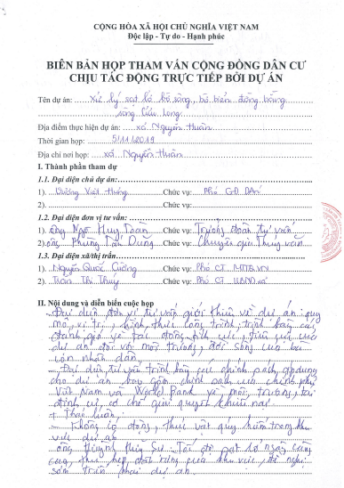
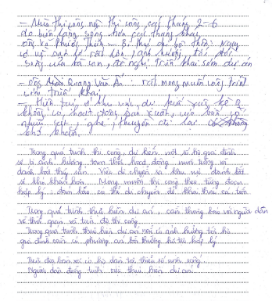
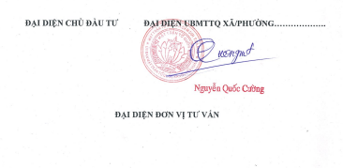
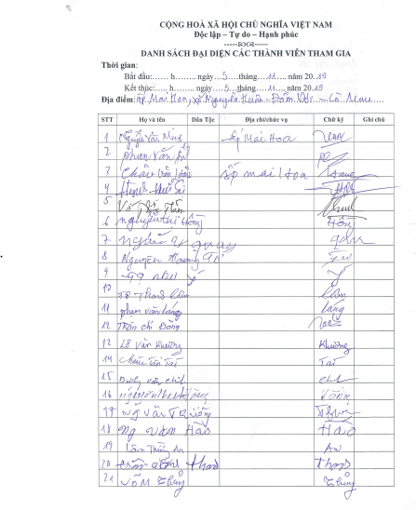
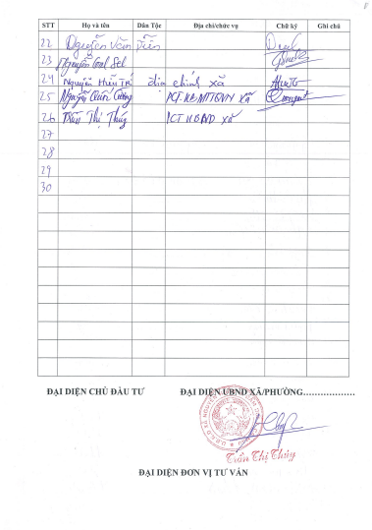

2/ Dat Mui commune
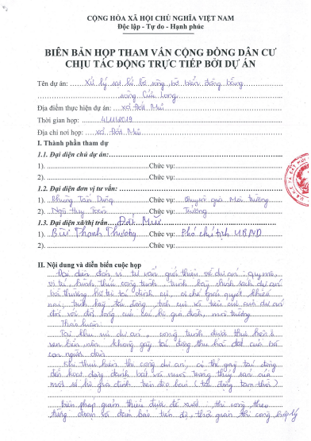
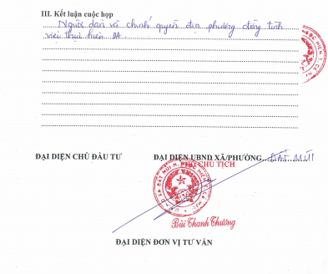
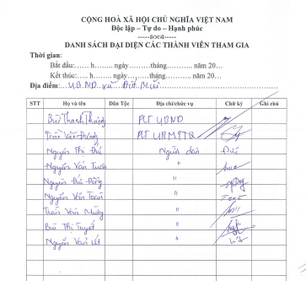
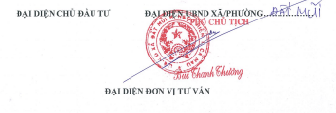

Annex 2: Some photos of the scene and community consultation
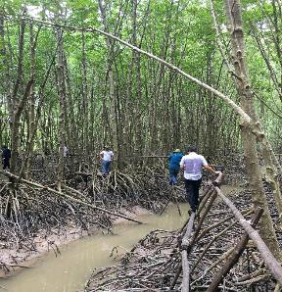 | 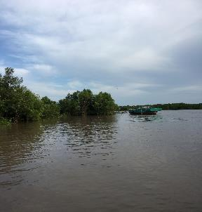
Ramsar biosphere reserve area | Vam Xoay estuary embankment area
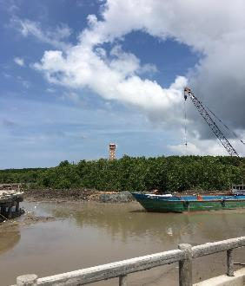
Vam Xoay estuary embankment area | Ho Gui estuary embankment area
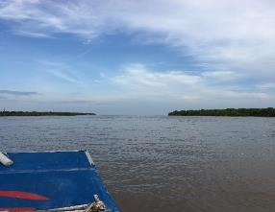 | 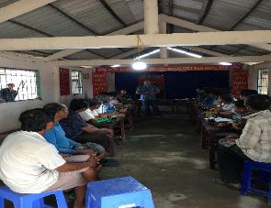
Ho Gui estuary embankment area | Consultation in Nguyen Huan commune
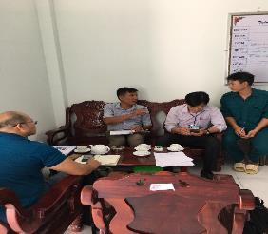 | 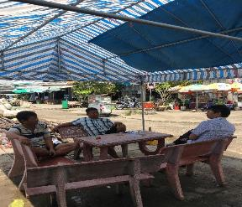
Consultation in Dat Mui commune
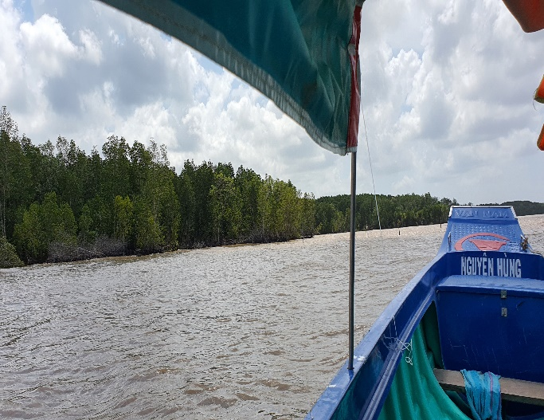 |  | 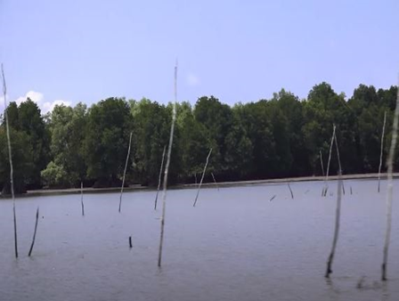
Coastal aquaculture activities
(bamboo/timber fences and netting around)

Annex 3: Project Information Booklet
(draft)
Introduction:
The Government of Vietnam has received a credit of the International Development Association (IDA) to finance the Mekong Delta Integrated Climate Resilience and Sustainable Livelihoods Project (MD-ICRSL Project). Subproject 01: "Addressing Coastal and Riverbank Erosion in Mekong Delta - Ca Mau Province" is part of Component 2 - Managing Upstream Floods - Mekong Delta Integrated Climate Resilience and Sustainable Livelihoods Project (MD-ICRSL Project).
Objective of the subproject
- General objectives: Overcoming erosion of river and coastal banks, protecting coastal population, infrastructure and land, enabling livelihoods stabilization and development, and improving incomes for people in the subproject area.
- Specific objectives: Eradicating erosion at selected critical (emergency) locations, promoting land and water management better and improving disaster resilience under climate change and sea level rise conditions in selected provinces in the Mekong Delta.
Components of the subproject
Subproject 1: "Addressing Coastal and Riverbank Erosion in Mekong Delta - Ca Mau Province" is proposed to build 02 work-items: “Embankment against landslides in Vam Xoay area” in Dat Mui commune, Ngoc Hien district with a length of 4.87 km, and “Embankment against landslides in Ho Gui area” in Nguyen Huan commune, Dam Doi district, with a length of 3.5 km.
It is preliminarily estimated that the embankment against landslides in Vam Xoay area, when being completed, will directly and indirectly protect 270 households (1080 people) in Vam Xoay estuary residential areas, protect Ho Chi Minh highway, high-voltage and medium-voltage lines, medical stations, schools..., as well as protect and restore the very important protective forest belt in the East Coast and the world biosphere reserve - the Ramsar area...
The “Embankment against landslides in Ho Gui area”, when being completed, is preliminarily estimated that it will protect 639 households (2,556 people) and 2,354 ha agricultural land and aquaculture land, directly and indirectly, in Ho Guoi estuary residential areas after the embankment is built. In addition, the construction of the embankment will help protect and restore the very important protective forest belt in the East Coast. The construction of the subproject is relevant with people’s expectation and help them stabilize their lives, which makes people feel secure in fishing and aquaculture production.
Impact scope
Surveys are underway to determine exact number of affected households. However, because the structures are built entirely out of the sea, there will be no significant land acquisition impact. It is anticipated that people’s farming and fishing activities are possibly affected.
Who are affected households (AHs)?
AHs are those who are living in the affected area at the date that the project is publicly announced. The cut-off-date for eligibility is the date of notification for land acquisition. Persons who encroach into the area after the cut-off-date will not be entitled to compensation or any other form of resettlement assistance.
What are the resettlement policies and principles of the Project for affected households?
The basic resettlement principles of the Project are:
a) All APs are entitled to be compensated for their lost assets, incomes and businesses at replacement cost, and provided with rehabilitation measures sufficient to assist them to improve or at least maintain their pre-project living standards, incomes and productive capacity.
b) Lack of legal rights to the assets lost will not prevent APs from entitlement to compensation.
c) Compensation for affected assets shall be provided at market rates.
d) Preparation of resettlement plans and their implementation is to be carried out with participation and consultation of affected people.
e) The compensation of assets and relocation of affected households must be completed before commencing any construction activities.
f) Specific supports will be provided to ethnic minority, female headed households, households with disable people and other vulnerable households.
Detailed Measurement Survey (DMS)
The DMS will only be carried out in the presence of the AHs. AHs will be informed prior to the survey.
Subproject schedule
When other consultations will take place?
Consultations with AHs will continue during the detailed design phase and before the DMS. AHs will receive written invitations to join public meetings.
If there are disagreements or problems arising during the subproject implementation such as subproject-related compensation or disputes, do I have the right to complain?
Any AHs may file complaints or grievances. The subproject includes a Grievance Redress Process and AHs may present their complaints to the concerned local administrative officials and RCs, either verbally or in writing.
A complaint can be filed at first at the commune level and elevated to the highest provincial level if the AH is not satisfied with the decisions made by the respective commune or district. AHs will be exempted from all taxes and administrative and legal fees associated with filing and resolving disputes.
Any questions or concerns about the project, please contact: The Irrigation Projects Central Management Office.
Address: 23 Hang Tre, Hoan Kiem, Ha Noi
Tel.: 04.38253921; Email: info@cpo.vn

Annex 4: IOL form

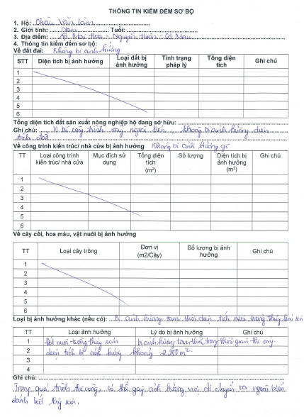
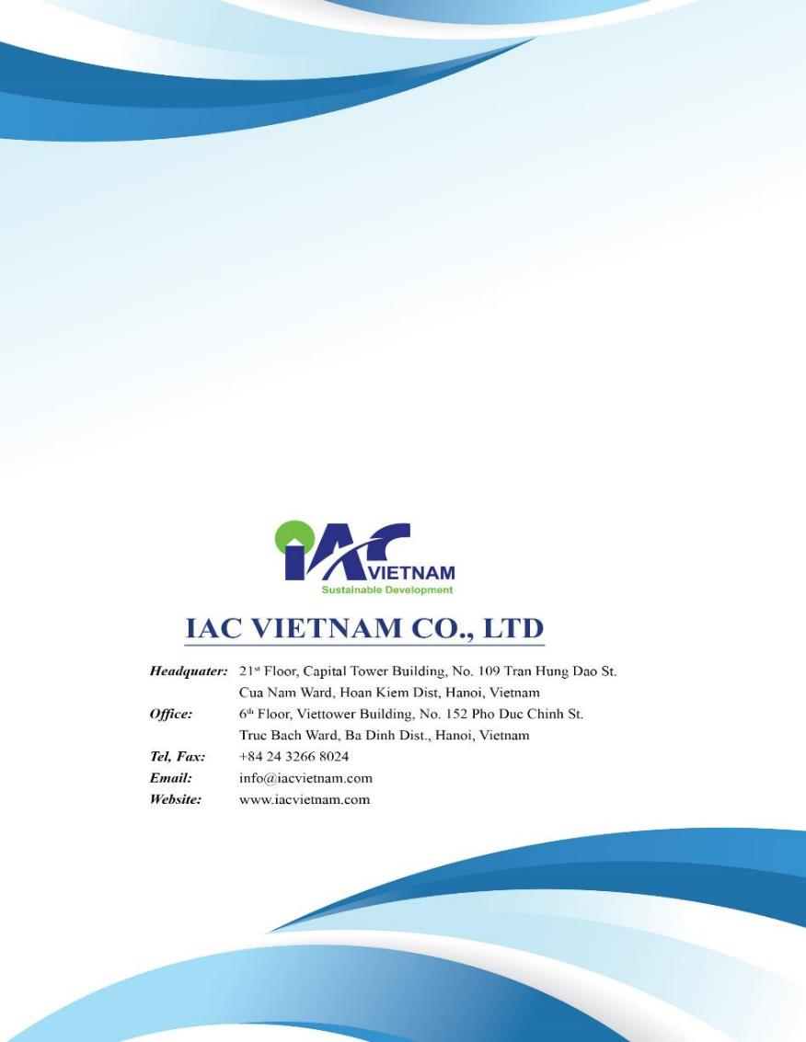

Based on the IOL and SES results, the average rented area of these HHs is from 5,000m2 – 7,000m2. The temporarily affected area is from 1,000 – 2,000m2 per HHs, the affected occupies a mall part of their total area. Therefore, before construction, the IAs (PMU and CPCs, LFDC...) will inform these HHs early (at least 3 months) so that they can move their clam cages into their remaining area to avoid affecting their production activities. Additionally, the IA will provide transportation assistance for these households.
Clause 1, Article 40, Decision No.62/2015/QD-UBND dated December 31, 2015 by the People's Committee of Ca Mau province providing compensation, support and resettlement when the State recovers land in Ca Mau province.
Source: Clause 5, Article 50, Decision No.62/2015/QD-UBND dated December 31, 2015 by the People's Committee of Ca Mau province providing compensation, support and resettlement when the State recovers land in Ca Mau province.

